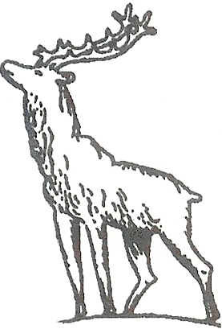

Dear Swimmer,

North Herts Primary Schools Swimming Team 2017

The Herts Schools’ Primary Inter District Gala will take place at Woodside Leisure Centre Pool, Watford on Friday 9th June 2017, starting at 7:30pm (warm up 7.00pm). In order to select a team to represent North Hertfordshire in this Gala, I am asking interested swimmers to complete the attached entry form and return it to me.

Age Groups
The competition is for Boys and Girls in two age groups:
Year 5: born between 01/09/06 and 31/08/07
Year 6: born between 01/09/05 and 31/08/06
A swimmer may NOT compete out of his/her age group.

Personal Best Times
Please ensure that you provide accurate details of your personal best times, to allow the strongest team to be selected.

Additional Information
There will be two swimmers for each individual event (heat declared winner).
Swimmers selected for the team will be asked to swim an individual and a relay.

Swimmers will need to make their own travel arrangements and to have a named adult responsible for their welfare while at the Gala.

Please check that the attached form has been signed by a parent/guardian and by your school’s Headteacher. If you have a query please contact me directly.

Confirmation of Teams
The teams will be finalised and letters/emails sent out to those swimmers who have been selected on Friday 19th May 2017.

Closing Date for Entries
The attached form should be returned to me by Wednesday 17th May 2017 at the latest.

Regards,

Mel Godfrey

North Herts Junior Rep.
58 Meadow Way
Letchworth GC
Herts, SG6 3HX
godfreys@btconnect.com

